1. Remove duplicate members from an array using Javascript without using any inbuilt functions?
2. Given an array with repeated elements/numbers, return an array of its index occurrences.

For ex: input = [1,3,1,6,1,8,2,1,0] ;

search for element = 1;

Output = [0,2,4,7];

1. 2 and 3 rd largest numbers in the given array

For ex : input = [3,6,2,9,1,32,97,-1,5]

Output : 32, 9

1. Write a program / function to compute the first nonrepeating char in the given string without using any inbuilt functions?

For ex : input = “asif shaik”

Output = f;

1. Write a program/function to sort the give array without using any inbuilt functions like .sort() or others
2. Given a numbered string like “8639412” convert it into the sorted string like”1234689”
3. Write a sum method which will work properly when invoked using either syntax below.

console.log(sum(2,3)); // Outputs 5

console.log(sum(2)(3)); // Outputs 5

1. Difference between for each vs for of vs for in vs array.map vs array.filter vs array.reduce
2. Draw the css Box model, it’s limitations and what is box-sizing: border-box;
3. Write the HTML,CSS code for the following template

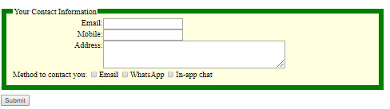

11.Difference between **display:block** and **display: inline-block**

12. What is **float: left** in css ?

13. What is a media query and explain it with pseudo code.

**Angular 2**

1. How to handle routing in Angular2? What are the main routing components?
2. How do you define optional fields in a TypeScript class?
3. What’s the difference between for..in and for..of?
4. How does the event emitter work in Angular 2? Explain it with pseudo code.
5. How do you use a JavaScript third party lib in an Angular 2 App?
6. What's the difference between RouterModule.forChild and RouterModule.forRoot?
7. What’s the difference between a promise and Observable?
8. How would you protect a component being activated through the router ?
9. How would you pass data from a parent component to a child component?
10. How are the services injected to your application? Explain the use case of services with pseudo code ?